APPENDIX D

SOLUTIONS TO PROBLEMS

D.1 (i) 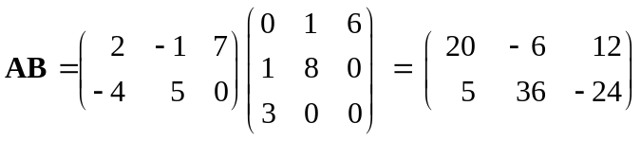

(ii) BA does not exist because B is 3 × 3 and A is 2 × 3.

D.2 This result is easy to visualize. If A and B are n × n diagonal matrices, then AB is an n × n diagonal matrix with j^{th} diagonal element a_{j}b_{j}. Similarly, BA is an n × n diagonal matrix with j^{th} diagonal element b_{j}a_{j}, which, of course, is the same as a_{j}b_{j}.

D.3 Using the basic rules for transpose,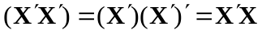, which is what we wanted to show.

D.4 (i) This follows from tr(BC) = tr(CB), when B is n × m and C is m × n. Take B = 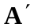 and C = A.

(ii) 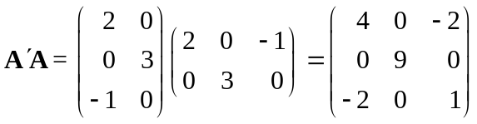; therefore, tr(A′A) = 14.

Similarly, 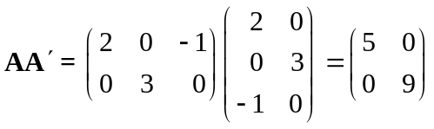, and so tr(AA′) = 14.

D.5 (i) The n × n matrix C is the inverse of AB if and only if C(AB) = I_{n} and (AB)C = I_{n}. We verify both of these equalities for C = B⁻¹A⁻¹. First, (B⁻¹A⁻¹)(AB) = B⁻¹(A⁻¹A)B = B⁻¹I_{n}B = B⁻¹B = I_{n}. Similarly, (AB)(B⁻¹A⁻¹) = A(BB⁻¹)A⁻¹ = AI_{n}A⁻¹ = AA⁻¹ = I_{n}.

(ii) (ABC)⁻¹ = (BC)⁻¹A⁻¹ = C⁻¹B⁻¹A⁻¹.

D.6 (i) Let e_{j} be the n × 1 vector with j^{th} element equal to one and all other elements equal to zero. Then straightforward matrix multiplication shows that 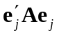 = a_{jj}, where a_{jj} is the j^{th} diagonal element. But by definition of positive definiteness, 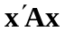> 0 for all x ≠ 0, including x = e_{j}. So a_{jj} > 0, j = 1,2, ,n.

(ii) The matrix A = 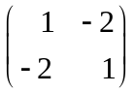 works because = −2 < 0 for x′ = (1 1).

D.7 We must show that, for any n × 1 vector x, x ≠ 0, x ′(P′AB) x > 0. But we can write this quadratic form as (P x)′A(P x) = z′Az where z ≡ Px. Because A is positive definite by assumption, z′Az > 0 for z ≠ 0. So, all we have to show is that x ≠ 0 implies that z ≠ 0. We do this by showing the contrapositive, that is, if z = 0 then x = 0. If Px = 0 then, because P⁻¹ exists, we have P⁻¹Px = 0 or x = 0, which completes the proof.

D.8 Let z = Ay + b. Then, by the first property of expected values, E(z) = Aµ_{y} + b, where µ_{y} = E(y). By Property (3) for variances, Var(z) = E[(z – µ_{z})(z – µ_{z}) ′]. But z – µ_{z} = Ay + b – (Aµ_{y} + b) = A(y – µ_{y}). Therefore, (z – µ_{z})′ = (y – µ_{y})′A′, and so (z – µ_{z})( z – µ_{z})′ = A(y – µ_{y})(y – µ_{y})′A′. Now we can take the expectation and use the second property of expected value: E[A(y – µ_{y})(y – µ_{y})′A′] = AE[(y – µ_{y})(y – µ_{y}) ′]A′ = A[Var(y)]A′.

